**Data Structures**

**Home Work-01**

Sajid Ali

21p-8023

Q1:

Code:

/*

The following code gets every value from the matrix we insert and in a second matrix it

it calculates the value for second matrix through conditions. There are different conditions for

corners, side rows and columns and middle values.

*/

#include<iostream>

using namespace std;

void print(float arr[6][6]){ // print function to print array

for(int i = 0; i < 6; i++){

for(int j = 0; j < 6; j++){

cout<<"\t" << arr[i][j];

}

cout<<endl;

}

}

int main(){

float arr[6][6];

float rArr[6][6];

int c = 1;

for(int i = 0; i < 6; i++){

for(int j = 0; j < 6; j++){

arr[i][j] = c;

c++;

}

}

print(arr);

cout << endl << endl;

for(int i = 0; i < 6; i++){ // loops to insert the values in every position

for(int j = 0; j < 6; j++){

if(i == 0 && j == 0){ // condition for top left corner

rArr[i][j] = ((arr[i][j+1] + arr[i+1][j]+ arr[i+1][j+1]) / arr[i][j]);

}else if(i == 0 && j <= 4){ // condition for top row

rArr[i][j] = ((arr[i][j-1] + arr[i][j+1] + arr[i+1][j-1]+ arr[i+1][j] + arr[i+1][j+1]) / arr[i][j]);

}else if(i == 0 && j == 5){ // condition for top right corner

rArr[i][j] = (arr[i][j-1] + arr[i+1][j-1] + arr[i+1][j]) / arr[i][j];

}else if(i <= 4 && j == 0){ // condition for left column

rArr[i][j] = ((arr[i-1][j] + arr[i-1][j+1] + arr[i][j+1]+ arr[i+1][j] + arr[i+1][j+1]) / arr[i][j]);

}else if(i == 5 && j == 0){ // condition for bottom left corner

rArr[i][j] = (arr[i-1][j] + arr[i-1][j+1] + arr[i][j+1]) / arr[i][j];

}else if(i == 5 && j <= 4){ // condition for bottom row

rArr[i][j] = (arr[i][j-1] + arr[i-1][j-1] + arr[i-1][j]+ arr[i-1][j+1] + arr[i][j+1]) / arr[i][j];

}else if(i == 5 && j == 5){ // condition for bottom right corner

rArr[i][j] = (arr[i][j-1] + arr[i-1][j-1]+ arr[i-1][j]) / arr[i][j];

}else if(i <= 4 && j == 5){ // condition for right column

rArr[i][j] = (arr[i][j-1] + arr[i-1][j-1] + arr[i-1][j]+ arr[i+1][j-1] + arr[i+1][j]) / arr[i][j];

}else{ // condition for mid entries

rArr[i][j] = (arr[i][j-1] + arr[i-1][j-1] + arr[i-1][j] + arr[i-1][j+1] + arr[i][j+1] + arr[i+1][j+1] + arr[i+1][j-1] + arr[i+1][j]) / arr[i][j];

}

}

}

print(rArr);

return 0;

}

Output:

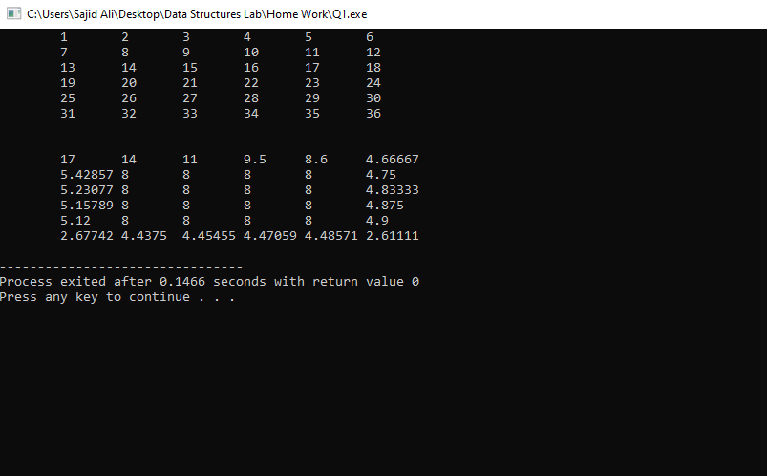

Q2:

Code:

/*

The following code will print the table of a user input number and it's limit using pointers

passing them into function.

*/

#include<iostream>

using namespace std;

void table(int* n, int* l){ // Funtion for table, passing the pointers

for(int i = 1; i <= *l; i++){

cout << *n << " * " << i << " = " << *n * i << endl;

}

}

int main(){

string c; // variable for loop continuity

do{

int num, lim;

int* n = &num; // pointer declaration

int* l = &lim;

cout << "Enter table number: "; // taking user input

cin >> *n;

cout << "Enter table limit: ";

cin >> *l;

table(n, l); // function call

cout << endl;

cout << "Do you want to continue?(y/n)"; // asking user if he wants to continue

cin >> c;

}while(c != "n");

return 0;

}

Output:

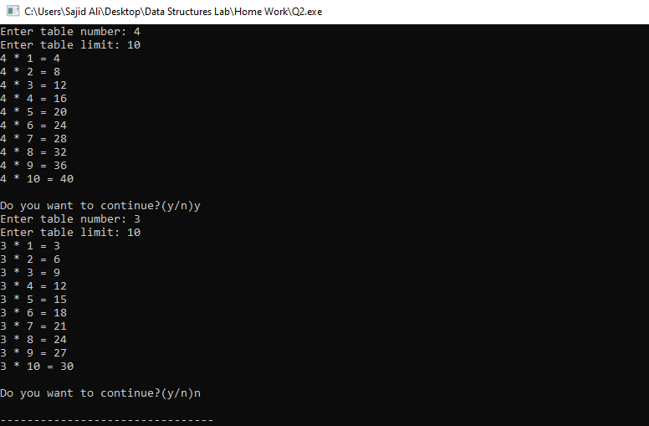

Q3:

Code:

/*

The following code reads data from a file and stores the data in 2D array

and stores the sum of rows in another array.

*/

#include<iostream>

#include<fstream>

using namespace std;

int main(){

string t;

int arr[5][5]; // array to store the data

int sum[5]; // array to store the sum

ifstream file("data.txt"); //opening file

for(int i = 0; i < 5; i++){ //inserting data from file into 2D array

for(int j = 0; j < 5; j++){

file >> t;

arr[i][j] = stoi(t);

}

}

file.close();

int add = 0;

for(int i = 0; i < 5; i++){ // calculating the sum and storing in summ array

for(int j = 0; j < 5; j++){

cout << arr[i][j] << " "; //displaying the data in array

add += arr[i][j];

}

cout << endl;

sum[i] = add;

add = 0;

}

cout << endl << "The Sum of rows is: "; // printing the sum array

for(int i = 0; i < 5; i++){

cout << "\t" << sum[i];

}

return 0;

}

Output:

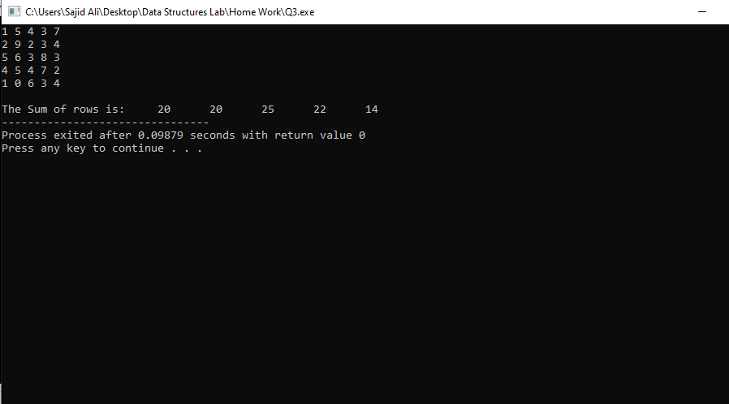

Q4(a):

Code:

/*

The following code checks if a password is valid or invalid.

*/

#include<iostream>

using namespace std;

int checklen(string temp){ //function to check the length

int c = 0;

if(temp.length()>=5 && temp.length()<=11){

c = 1;

}

return c;

}

int checkCap(string temp){ //function to check capital letter in password

int c = 0;

for(int i = 0; i < temp.length(); i++){

if(isupper(temp[i])){

c = 1;

break;

}

}

return c;

}

int checkDigit(string temp){ //function to check digit in password

int c = 0;

for(int i = 0; i < temp.length(); i++){

if(isdigit(temp[i])){

c = 1;

break;

}

}

return c;

}

int checkChar(string temp){ //function to check special character in password

int c = 0;

for(int i = 0; i < temp.length(); i++){

if(ispunct(temp[i])){

c = 1;

break;

}

}

return c;

}

int main(){

string temp;

int n = 0; // flag

cout << "Please set your password: ";

cin >> temp;

do{

n = 1; //flag set to 1

if(checklen(temp) == 0){

cout << "The length of your password should greater than 5 and less than 11! \n";

n = 0; //flag set to 0 due to length

}

if(checkCap(temp) == 0){

cout << "There should be atleast one capital letter in your password! \n";

n = 0; //flag set to 0 due to missing capital letter

}

if(checkDigit(temp) == 0){

cout << "There should be atleast one digit in your password! \n";

n = 0; //flag set to 0 due to missing digit letter

}

if(checkChar(temp) == 0){

cout << "There should be atleast one special character in your password! \n";

n = 0; //flag set to 0 due to missing special character letter

}

if(n == 0){

cout << "\nTry again: ";

cout << endl;

cin >> temp;

}

}while(n == 0);

if(n == 1){

cout << "\nPassword is Valid";

}

return 0;

}

Output:

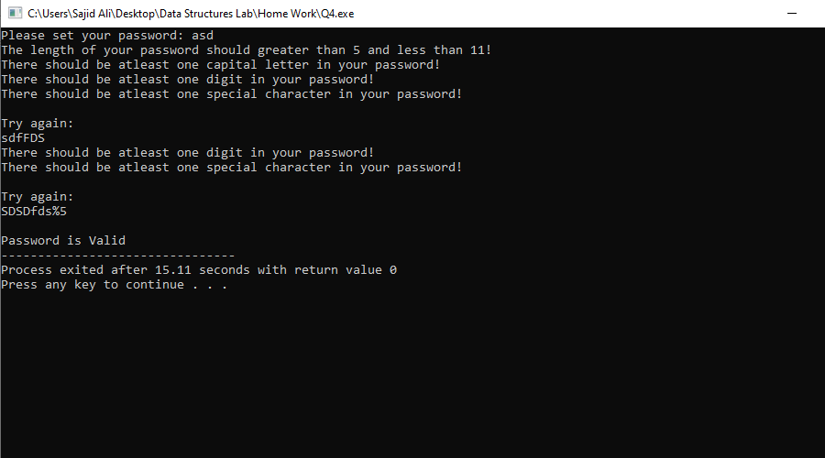

Q4(b):

Code:

/*

The following code checks if a email is valid or invalid using regex.

*/

#include<iostream>

#include<regex>

using namespace std;

bool emailCheck(string email){ //function to check an email

string regexpattern = "[a-zA-Z]+[-_.]?[a-zA-Z]+@[a-zA-Z]+\\.[com||COM]+";

regex regexRule(regexpattern);

return regex_match(email,regexRule);

}

int main(){

string email;

cout << "Enter email: ";

cin >> email;

if(emailCheck(email)){ //email is valid if function returns true

cout << "Email is valid!";

}else{

cout << "Email is invalid!";

};

return 0;

}

Output:

